**Key assignment congruency analysis**

As well as assessing the effect of presentation congruency, we also analysed the effect of key assignment congruency. Hand and number size were combined into a composite variable to assess whether the congruency of the key assignment had any effect on reaction times. Individual mean reaction times were entered into a key assignment congruency (congruent vs incongruent) x presentation congruency (congruent vs congruent) x number presentation (symbolic vs non-symbolic) Repeated Measures ANOVA. A significant main effect of presentation congruency [F(1, 51) = 40.01, p < 0.001, = .440] and number presentation [F(1, 51) = 9.72, p = 0.003, = .160], and a key assignment congruency x number presentation interaction [F(1, 51) = 7.50, p = 0.008, = .128]. Regardless of the presentation congruency, symbolic numerals were reacted to slower when the key assignment was incongruent. This is highlighted in Figure 6.

*Figure 6: Mean reaction times with error bars representing SEM for congruent (A) and incongruent (B) presentation conditions.*

**Semantic congruency**

**Some notes on this:**

Not sure this analysis is possible as I don’t have the information to filter correctly. For example, here I have the congruent conditions. The diagonals from left to right are fully congruent.

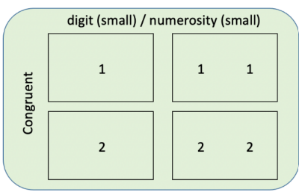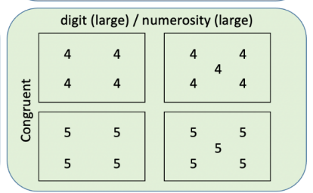

However the **digits condition** only has two fully congruent conditions (a 1 presented once, and 4 presented four times). Similarly, numerosity only has two fully congruent conditions (a 2 presented twice, and a 5 presented 5 times). So when it comes to doing the linear regression analysis for Digits and Numerosity, I only have numbers 1 and 4 for Digits and 2 and 5 for numerosity to perform the analysis, which is not suitable.

Am I missing something here? Or have a found an issue in performing the analysis. Hopefully I have managed to explain myself sufficiently to articulate my problem!

Next, we further investigated the congruent presentation condition by investigating the semantic congruency. This was done by categorising stimuli as fully congruent and partially congruent. Fully congruent stimuli were stimuli where the digit and numerosity perfectly matched (i.e. the number 1 digit was presented just once, the number 2 digit presented twice). Conversely, partially congruent stimuli were stimuli where the digit and numerosity only partially matched (i.e. the number 1 digit being presented twice; the numerosity is still small but presenting the number 1 twice is not semantically congruent). This analysis was conducted for symbolic and non-symbolic numerals.

**Symbolic**

Individual reaction times for the digits conditions were entered into a response hand (left vs right), number magnitude (small vs large), and semantic congruency (full vs partial) in a Repeated Measures ANOVA. A significant hand x number magnitude interaction was found [F(1, 51) = 6.02, p = 0.018, = .106] which provides evidence for SNARC effect for partially and fully semantically congruent conditions (see Figure X). There was also a significant interaction between number magnitude and semantic congruency [F(1, 51) = 23.89, p < 0.001, = .319]. This is evident in Figure 7 by as responses to large number magnitudes within the fully congruent condition being slower in comparison to large number magnitudes in the partially congruent condition.

*Figure 7: Mean reaction times with error bars representing standard error of the mean (SEM) for fully (A) and partially (B) congruent conditions in the symbolic task.*

**Non-symbolic**

Individual reaction times for the numerosity conditions were entered into a response hand (left vs right), number magnitude (small vs large), and semantic congruency (full vs partial) in a Repeated Measures ANOVA. Only a significant main effect of number magnitude was found whereby large numbers were responded to faster than smaller numbers [F(1, 51) = 11.30, p = 0.001, = .181]. No evidence for a SNARC effect was found for non-symbolic numerals (see Figure 8).

*Figure 8: Mean reaction times with error bars representing SEM for fully (A) and partially (B) congruent conditions in the non-symbolic task.*